**2019 Year 11 Physics**

**Task 10: Test 5 – Motion**

Name: \_\_\_\_\_\_\_\_\_\_\_\_\_\_\_\_\_\_\_\_\_\_

\_\_\_\_\_\_\_ / 47

(3 marks)

From your home, you drive 10.0 km East to pick up one friend then 27.00 km West to pick up another person.

## What distance did you travel from home? (1 marks)

10 + 27 = 37 km.

## Using a diagram, show what your displacement is from home. (2 marks)

Diagram (1)

17.0 km West (1)

(3 marks)

The end of recess bell has gone and Stephen Hawking (RIP) now has 1 minute 50 seconds to get to his Physics class. He can motor at a constant 5.30 ms-1 and he needs to travel a displacement of 4.00 x 102 m West. Will he make it in time?

t = 1.5 minutes = 110 s s = vt

v = 5.3 ms-1 t = s/v

s = 4.00 x 10 2 m = 4.00 x 10 2 / 5.3 (1)

(1) = 75.5 s

= yes will get there on time. (1)

(2 marks)

Bodhi the dog is walking through the bush at 1.44 m s-1 when he sees a cow eating in front of him. If he accelerates at 3.60 m s-2 for 3.75 s to reach the cow, what was his velocity when he reached the cow?

u = 1.44 ms-1 v = u + at

a = 3.6 ms-2 = 1.44 + 3.6 x 3.75 (1)

t = 3.75 s = 14.9 ms-1 (1)

v = ?

(6 marks)

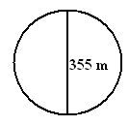Albert and Isaac are exercising together in a large park. Within the park is a circular path with another path which is 355 m long that acts as a diameter to the circle. The diagram illustrates this situation.

## Albert and Isaac are running across the diameter 355 m from one side of the circular path to the other at a speed of 6.00 m s-1. How long will it take them to run this path?

## (1 mark)

s = 355 m t = s/v

v = 6.00 ms-1 = 59.2 s (1)

t = ?

## Albert stops to rest at the other side, but Isaac continues to run at a speed of 6.00 m s-1 on the circular part of the path. During this time, is Isaac accelerating? Fully Explain.

## (3 marks)

Yes because acceleration is rate of change of velocity. (1)

Velocity is a vector (1)

Velocity is changing (direction). (1)

\_\_\_\_\_\_\_\_\_\_\_\_\_\_\_\_\_\_\_\_\_\_\_\_\_\_\_\_\_\_\_\_\_\_\_\_\_\_\_\_\_\_\_\_\_\_\_\_\_\_\_\_\_\_\_\_\_\_\_\_\_\_\_\_\_\_\_\_\_\_\_\_\_\_\_\_\_\_\_\_\_\_\_\_\_\_\_\_\_\_\_\_\_\_\_\_\_\_\_\_\_\_\_\_\_\_\_\_\_\_\_\_\_\_\_\_\_\_\_\_\_\_\_\_\_\_\_\_\_\_\_\_\_\_\_\_\_\_\_\_\_\_\_\_\_\_\_\_\_\_\_\_\_\_\_\_\_\_\_\_\_\_\_\_\_\_\_\_\_\_\_\_\_\_\_\_\_\_\_\_\_\_\_\_\_\_\_\_\_\_\_\_\_\_\_\_\_\_\_\_\_\_\_\_\_\_\_\_\_\_\_\_\_\_\_\_\_\_\_\_\_\_\_\_\_

## Isaac returns to Albert and the pair now run back down the diameter path firstly starting slowly (Isaac is tired) at 2.80 m s-1 but, being competitive, accelerates uniformly to a final velocity of 8.25 m s-1 at the end of the 355 m.

## What was their acceleration? (2 marks)

u = 2.80 ms-1 v2 = u2 + 2 as

v = 8.25 ms-1 (8.25)2 = (2.80)2 + 2 x a x 355

s = 355 m a = 8.48 x 10-2 ms-2 in direction of travel.

a= ?

(1 mark) (1 mark)

(4 marks)

A child is playing with Marvin the toy robot, which is travelling at 2.00 m s-1. The child increased the velocity to 5.00 m s-1 in 0.500 s.

How far did the toy travel in this time?

u = 2.00 ms-1 a = (v-u)/t

v = 5.00 ms-1 = (5 – 2)/0.5

t = 0.500 s 6.0 ms-2

s = ? (2)

s = ut + ½ at2

= 2 x 0.5 + ½ x 6 x (0.5)2

= 1.75 m

(2)

(5 marks)

Galileo is late for work again and is travelling at 1.00 x 102 km h-1 (speed limit 60.0 km h-1) when he sees a car coming in the opposite direction flashing it’s lights. Assuming that there is a speed gun ahead he starts to slow down (assume his reaction time before he started to brake was 1.65 s). He is decelerating at 4.80 m s-2 when, having very sharp eyes, he sees the speed gun. If he travelled 88.0 m from the time that he saw the car lights flash to the time he is registered on the speed gun, will he be booked?

u = 1.00 x 10 2 kmh-1 = 27.78 ms-1 Distance travelled before braking

reaction time = 1.65 s s = vt

a = -4.80 ms-2 = 27.78 x 1.65

= 45.83 m (1)

Distance decelerating = 88.0 – 45.83

= 42.17 m (1)

v2 = u2 + 2 as

= (27.78)2 + 2 x -4.80 x 42.17

= 771.7284 – 404.832 (1)

v = 19.15 ms-1

= 68.96 kmh-1

Speeding!! (2)

(4 marks)

A squash player hits the ball at a speed of 35.0 m s-1 at an angle of 30° to the side wall of the court. The ball rebounds at 120° to the original direction at a speed of 27.5 m s-1.

What is the change in velocity?

Hint: use scale diagram.

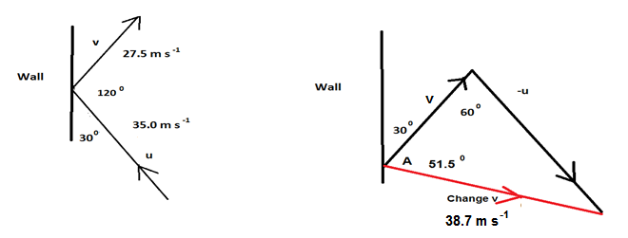

Calculation: using non right angle rules

Diagram **(1 mark)**

**Δv** **= ([-u]2 + v2 – 2 [-u]v cos 600)0.5**

**Δv** **= 31.92 m s-1** **(1 mark)**

**35 = 31.92**

**sin A sin 60 (1 mark)**

**A = 71.7°inside the triangle + 30° = 101.7°****(1 mark)**

**Calculation taking components.**

**X Y**

**V Cos(60) 27.5 Sin(60) 27.5 (1 mark)**

**13.75 23.81**

**U Cos(60) 35 Sin(60) 35 (1 mark)**

**-17.5 30.3**

**Δv** **= V-U 31.25 -6.49 Resultant: 31.92ms-1 (1 mark)**

**Angle tan-1(6.49/31.25) 11.73° + 90° = 101.7° (1 mark)**

(3 marks)

Sir William Lawrence Bragg is sitting 13.2 m up in the branches of a tree throwing water bombs on people walking underneath. When his Dad, Sir William Henry Bragg (whose head is 1.20 m above the ground) is walking under the tree young Willy throws a water bomb down at his head with an initial velocity of 3.40 m s-1.

How long does young Willy have to hide in the branches, once he has thrown the bomb, so that his Dad can’t see him?

**s = 13.2 m – 1.20 m = 12.0 m v2 = u2 + 2 as**

**u = 3.40ms-1 = (3.40)2 + 2 x 9.8 x 12**

**a = 9.8 ms-2 = 11.56 + 235.2**

**t = ? v = 15.69 ms-1**

**(1 mark) (1)**

**t = (v-u)/a**

**= (15.69 – 3.40)/9.8**

**= 1.25 s (1)**

(5 marks)

The Golden Dragon is one of the best fliers of all dragons. Below is the graph of one particular dragon as he and his rider take a short trip from one dragon lair to another.

AN03622_



## Calculate the acceleration (in m s-2) of the dragon between 20.0 and 24.0 minutes.

## (2 marks)

**Acceleration = slope of graph.**

**v = 0 a = (v-u)/t (1 mark)**

**u = 60.0 kmh-1 = 16.67 ms-1 = -16.67/240**

**t = 4 minutes = 240 s = -0.0695 ms-2**

**= 6.95 x 10-2 ms-2 deceleration (1 mark)**

## Calculate the displacement of the dragon from the graph above. (3 marks)

**Displacement = Area under the graph**

**s = ½ x 480 x 16.67 + 720 x 16.67 + ½ x 240 x 16.67**

**= 4000.8 + 12002.4 + 2000.4**

**= 18003.4**

**= 18.0 km (3)**

(5 marks)

During a basketball practice session, a player shoots a basketball up to the rim above. The ball is 1.80 m above the ground when it is released with an initial velocity of 3.40 m s-1 directly upwards. The shot misses the rim and the ball hits the court before being picked up by another player.

How long was the ball in the air?

**u= 3.4 ms-1 to peak**

**a = 9.81 ms-2 down**

**v2 = u2 + 2 as**

**0 = (3.4)2 + 2 x -9.81 x s**

**s = 0.589 m (1)**

**t = (v – u)/a**

**= 0.3465s to peak (1)**

**Total s = 1.8 + 0.589**

**= 2.389 m (1)**

**s = ut + ½ at2**

**2.389 = ½ x 9.8 x t2 (1)**

**t = 0.6982 s (1)**

**Total time t = 1.0447 s**

**Or solve as a quadratic**

**u = 3.4 (up) t = ? s = -1.8**

**g=-9.81**

**s = ut + ½ at2**

**-1.8 = 3.4 t + ½ 9.81 t2 Rearranging**

**0 = 1.8 + 3.4 t - 4.9 t2**

**Using quadratic equations**

$$x=\frac{-b±\sqrt{b^{2}-4ac}}{2a}$$

**Substitutes to:**

$$t=\frac{-3.4±\sqrt{{3.4}^{2}-4×-4.9× 1.8}}{2× -4.9}$$

**t = -0.35 seconds or 1.045 seconds**

**Total time: t = 1.045 seconds**

(9 marks)

A keen bushwalker went for an extended hike as shown by the following graph.

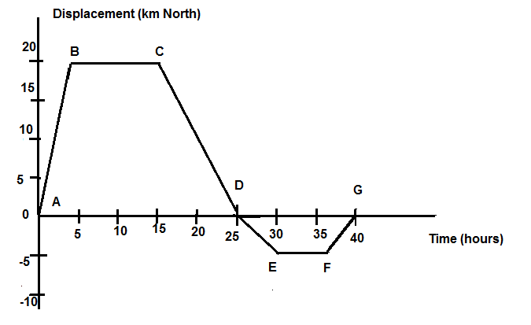

Use the graph to determine the following information:

## How far did the hiker walk? (1 mark)

20 + 20 + 5 + 5 = 50 km

## Calculate the velocity (km h-1) in the following segments:

## (i) AB (1 mark)

## **s = 20, t = 5 hours v = s / t**

## **v = 20 / 5**

**v = 4 km h-1**

## (ii) EF (1 mark)

## **s = 0, t = 5 hours v = s / t**

## **v = 0 / 5**

**v = 0 km h-1**

## (iii) AG (1 mark)

## **s = 0, t = 40 hours v = s / t**

## **v = 0 / 40**

**v = 0 km h-1**

## (iv) DE (1 mark)

## **s = -5, t = 5 hours v = s / t**

## **v = -5 / 5**

**v = -1 km h-1**

## Draw a graph of velocity versus time. (3 marks)

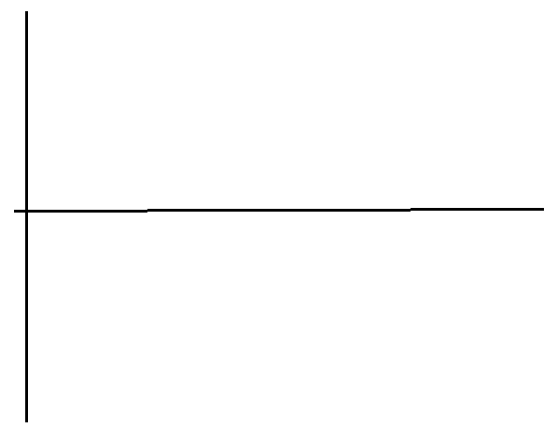

## For how long was the walker stationery? (1 mark)

## **During BC (10 hours) and EF (5 hours), 15 hours**